Exception handling Lab Questions

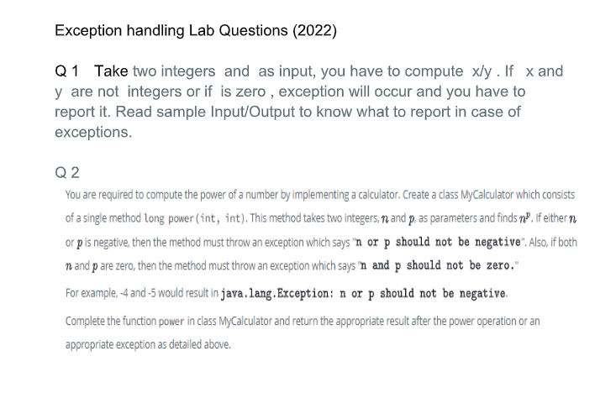

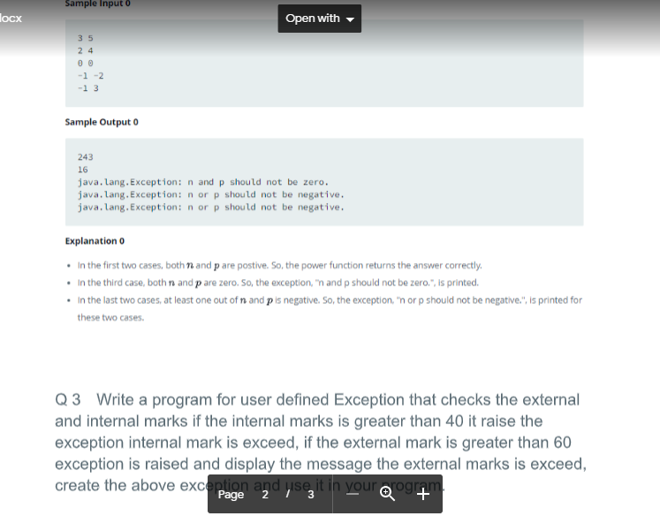

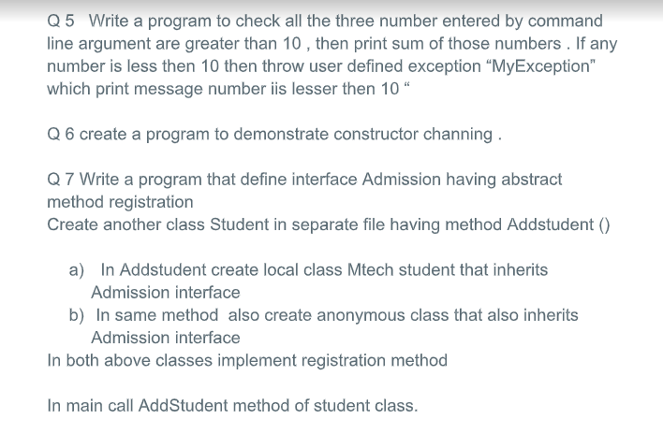

Solution

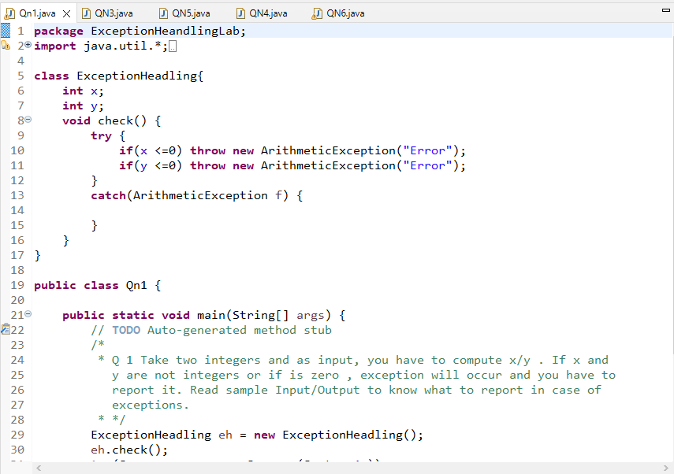

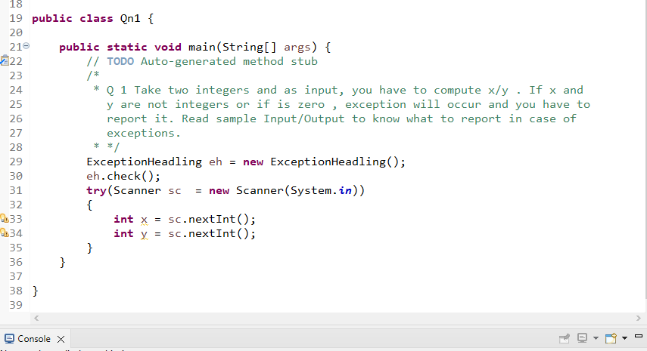

Q 3 Write a program for user defined Exception that checks the external

and internal marks if the internal marks is greater than 40 it raise the

exception internal mark is exceed, if the external mark is greater than 60

exception is raised and display the message the external marks is exceed,

create the above exception and use it in your program.

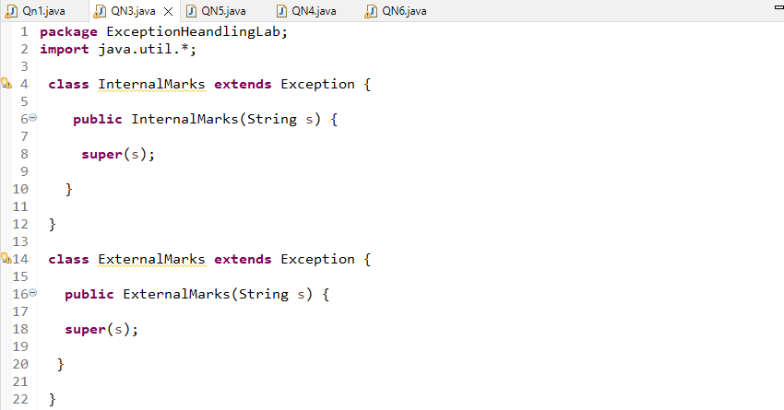

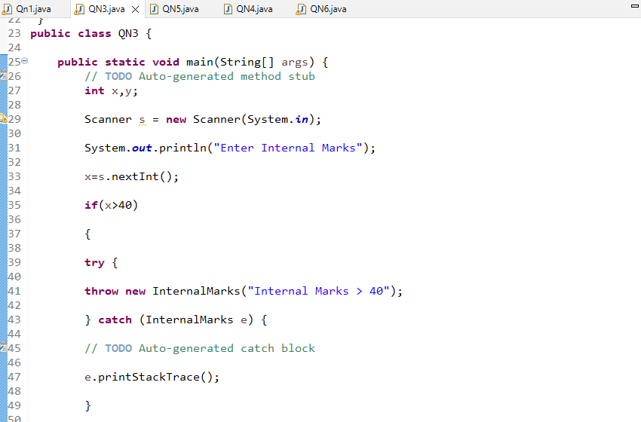

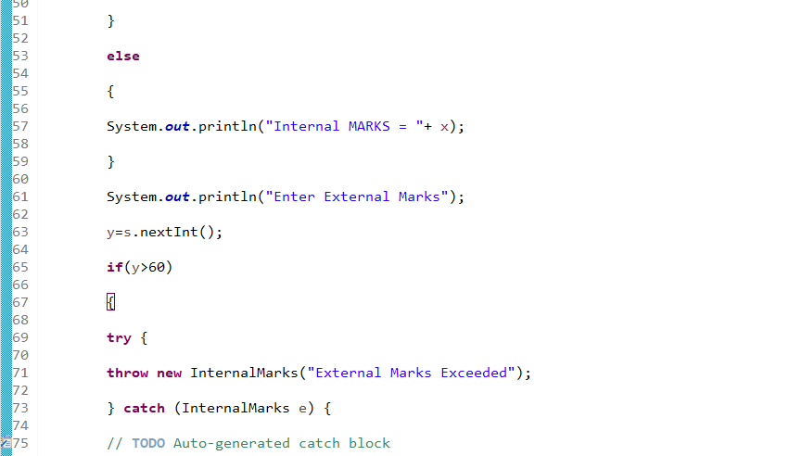

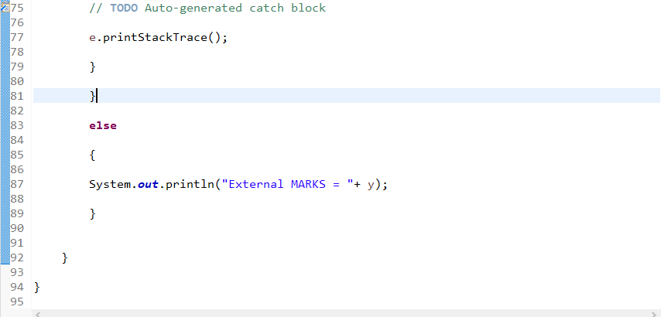

Output

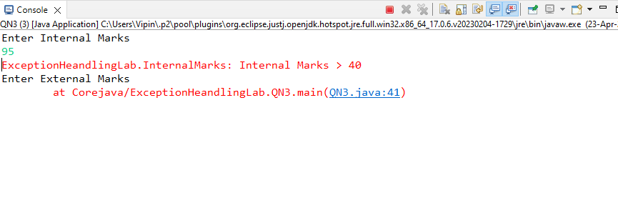

Q 4 Create a class Student with attributes roll no, name, age and

course. Initialize values through parameterized constructor. If age of

student is not in between 15 and 21 then generate user-defined exception

“AgeNotWithinRangeException”. If name contains numbers or special

symbols raise exception” NameNotValidException ”.

Solution

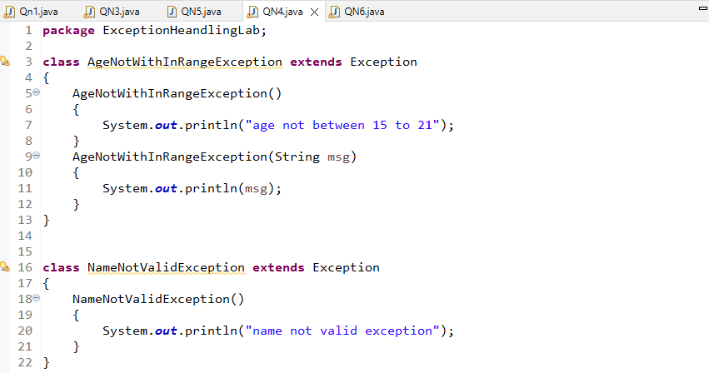

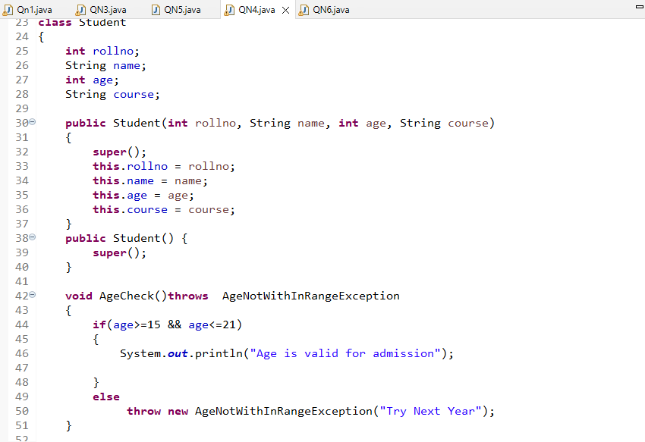

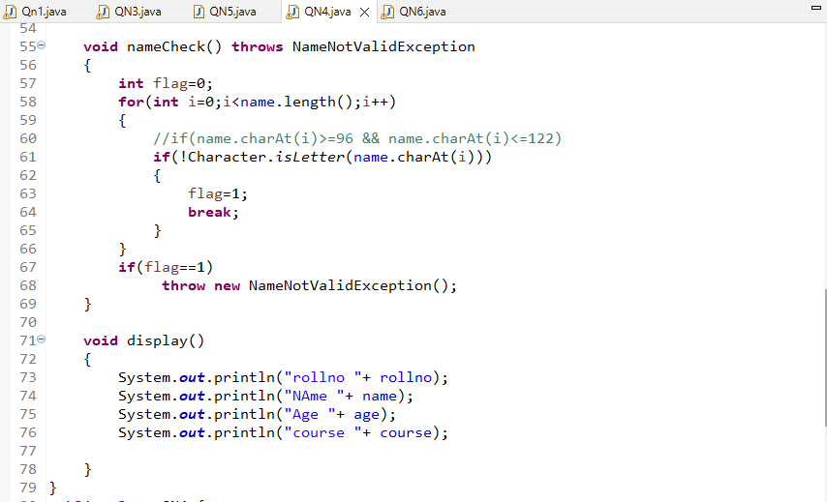

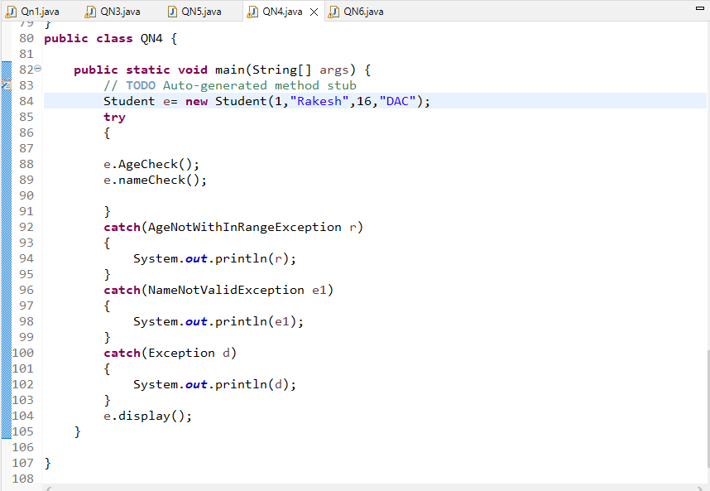

Output

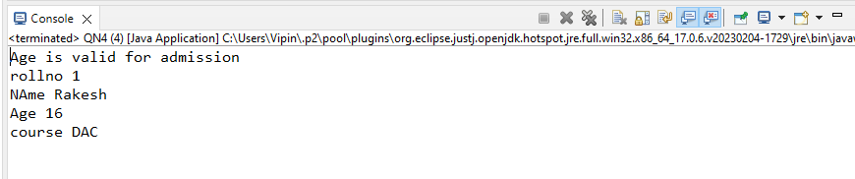

Q 5 Write a program to check all the three number entered by command

line argument are greater than 10 , then print sum of those numbers . If any

number is less then 10 then throw user defined exception “MyException”

which print message number iis lesser then 10 “

Solution

Q 6 create a program to demonstrate constructor channing .

Solution

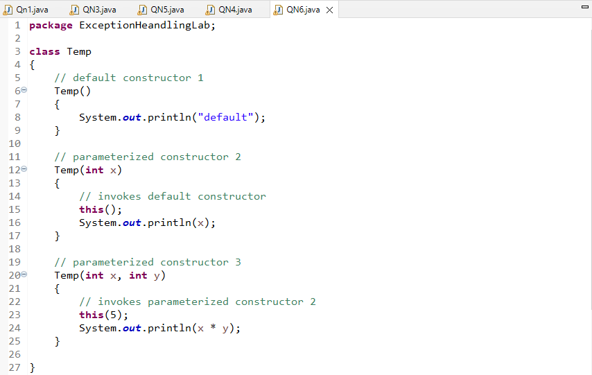

Output

